Defect Report Register
This serves as a Defect Report Register is to document, track, communicate, and manage defects identified during testing activities of Flash-Guard. It provides a centralized record of issues discovered within the application, enabling effective collaboration between team members.
This document assists in:
- Tracking defects throughout their lifecycle.
- Communicating issues clearly and consistently.
- Prioritizing defect resolution based on business impact and risk.
- Providing evidence to support defect investigation and root cause analysis.
- Monitoring product quality and release readiness.
- Maintaining an audit trail of testing outcomes and defect history.
All defects identified during testing should be recorded using the template below and assigned a unique identifier for traceability.

UI Defects

Defect ID | Summary | Expected Result | Actual Result | Severity | Priority | Status
DEF-UI-001 | Notification Button Not Functional | Clicking notification icon should display notifications panel | Notification icon performs no action | Medium | Medium | Open
DEF-UI-002 | CSV Export Unavailable with No Transactions | User should be able to export report or receive graceful handling | System displays “No transactions to export” | Low | Medium | Open
DEF-UI-003 | PDF Export Opens Print Preview | Export should generate downloadable PDF | Browser print preview opens instead | Low | Low | Open
DEF-UI-004 | Recent Transaction Records Lack Detail | Transactions should contain meaningful descriptions | Transactions display generic labels such as “Transfer #1” | Medium | Medium | Open
DEF-UI-005 | Incorrect Transaction Dates Displayed | Transaction dates should reflect actual transaction date | Transactions displayed in July while testing occurred in May | High | High | Open
DEF-UI-006 | Profile Management Functionality Missing | User should be able to update profile information | Profile management functionality unavailable | Medium | Medium | Open
DEF-UI-007 | Unable To Update User Profile | Clicking profile icon should open profile page | Profile icon does not respond | Medium | Medium | Open
DEF-UI-008 | Unable To Change Password | User should be able to access password settings | Password settings unavailable | Medium | Medium | Open

Mobile Defects
Defect ID | Summary | Expected Result | Actual Result | Severity | Priority | Status
DEF-MOB-001 | Custom Airtime Amount Cannot Be Entered | User should enter custom airtime amount | Only preset amounts available | Medium | High | Open
DEF-MOB-002 | Airtime Purchases Fail | User should purchase airtime successfully | Purchase fails | Critical | High | Open
DEF-MOB-003 | Data Purchases Fail | User should purchase data successfully | Purchase fails | Critical | High | Open
DEF-MOB-004 | Transaction Descriptions Not Meaningful | Transactions should display meaningful details | Generic transaction labels displayed | Medium | Medium | Open
DEF-MOB-005 | Incorrect Transaction Dates Displayed | Transaction dates should match actual dates | Future dates displayed | High | High | Open
DEF-MOB-006 | Biometric Login Not Working | User should authenticate using biometrics | Authentication unavailable | High | High | Open
DEF-MOB-007 | Session Timeout Not Triggered | Application should log out inactive users | Session remains active indefinitely | High | High | Open
DEF-MOB-008 | Balance Refresh Functionality Missing | User should refresh balance | No refresh functionality available | Medium | Medium | Open

API Defects
Defect ID | Summary | Expected Result | Actual Result | Severity | Priority | Status
DEF-API-001 | Invalid JWT Token Accepted | API should reject invalid tokens | API returned 200 OK | Critical | High | Open
DEF-API-002 | Rate Limiting Not Enforced | Excessive requests should return 429 | API continues processing requests | Medium | Medium | Open
DEF-API-003 | Authorisation Middleware Missing | Unauthorised users should be blocked | Authorisation controls missing | Critical | High | Open
DEF-API-004 | Shared Password Authentication Risk | Users should authenticate using unique credentials | Shared credential model used | High | High | Open
DEF-API-005 | Base64 Used as Encryption | Sensitive data should be encrypted | Base64 encoding used as security mechanism | High | High | Open
DEF-API-006 | Direct Balance Modification Endpoint Exposed | Balances should only change through transactions | Endpoint allows direct modification | Critical | High | Open
DEF-API-007 | Transfer Authorisation Race Condition | Concurrent transfers should be prevented from bypassing controls | Potential balance validation bypass exists | Critical | High | Open
DEF-API-008 | Profile Update Returns Incorrect Data | Updated profile details should be returned accurately | Incorrect profile information returned | High | High | Open

Database Defects
Defect ID | Summary | Expected Result | Actual Result | Severity | Priority | Status
DEF-DB-001 | Negative Account Balance Allowed | Account balances should never become negative | Negative balance recorded | Critical | High | Open
DEF-DB-002 | Logout Audit Event Missing | Login and logout activities should be logged | Logout records missing | Medium | Medium | Open
DEF-DB-003 | Failed Compliance Transactions Processed | Failed compliance checks should block transaction | Transaction continues processing | Critical | High | Open
DEF-DB-004 | Self-Transfer Allowed | Sender and recipient should not be same account | System allows self-transfer | High | High | Open

Defect Summary
Category | Count
UI Defects | 8
Mobile Defects | 8
API Defects | 8
Database Defects | 4
Total Defects Identified | 28

Highest Risk Findings
- Invalid JWT Token Accepted
- Direct Balance Modification Endpoint Exposed
- Negative Account Balance Allowed
- Failed Compliance Transactions Processed
- Transfer Authorisation Race Condition
- Airtime Purchases Fail
- Data Purchases Fail
- Biometric Login Not Working
- Self-Transfer Allowed
- Incorrect Transaction Dates Displayed

Recommendations
- Implement JWT validation middleware across all protected endpoints.
- Introduce role-based authorisation controls.
- Replace Base64 encoding with proper encryption mechanisms.
- Remove direct balance modification endpoints.
- Implement transaction locking and concurrency controls.
- Prevent negative balances through database constraints.
- Record all authentication and logout events within audit logs.
- Fix mobile service purchase workflows.
- Implement session timeout controls.
- Include automated UI, API, Mobile, and SQL validation within CI/CD pipelines.

Severity | Description
Critical | System crash, security vulnerability, data corruption, or complete business process failure.
High | Major functionality unavailable with no workaround.
Medium | Functionality impacted but workaround exists.
Low | Minor issue with little or no business impact.

Priority | Description
High | Must be fixed before release.
Medium | Should be fixed during the current sprint or release cycle.
Low | Can be scheduled for a future release.

Status
Current state of the defect.
Common statuses include:
- Open
- In Progress
- Ready for QA
- Retest
- Closed
- Deferred
- Duplicate
- Rejected
- Cannot Reproduce
- Blocked

Assigned To
Developer, team, or individual responsible for investigating and resolving the defect ( THIS WOULD BE MR A )

Recommended Supporting Evidence with defect ID
Where applicable, attach:
- Screenshots
- Screen recordings
- Browser console logs
- API request and response logs
- Database query results
- Error stack traces
- Test execution reports
- Build/version information
Evidence:
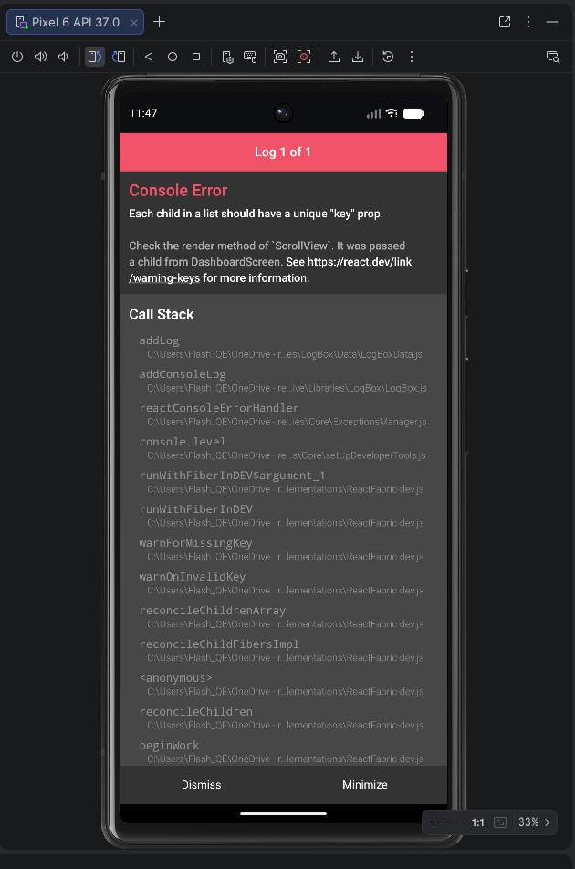
Mobile application console error (“Each child in a list should have a unique key prop”) indicating a React rendering defect

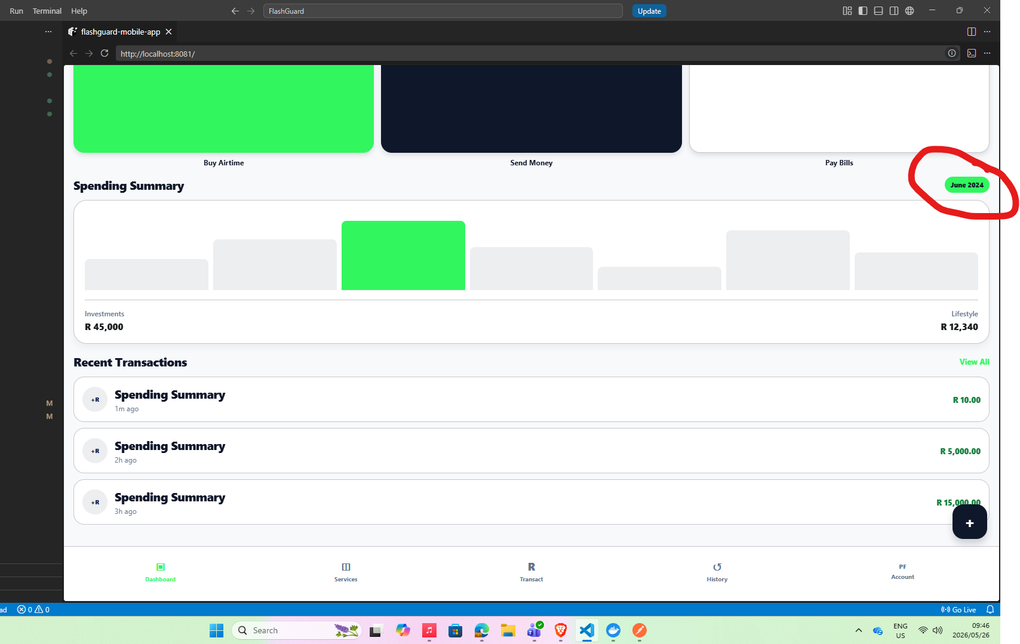
Incorrect transaction/report date displayed (June 2024 shown despite testing period mismatch)

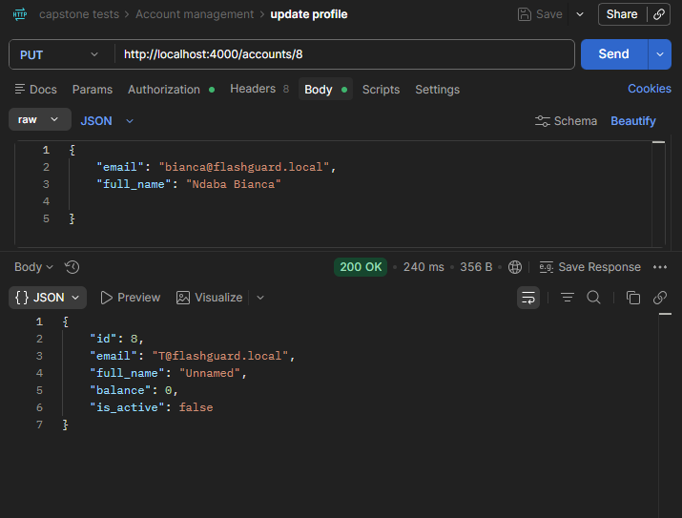
Profile Update Returns Incorrect Data (request updates Bianca’s details but response returns incorrect account information and “Unnamed”)

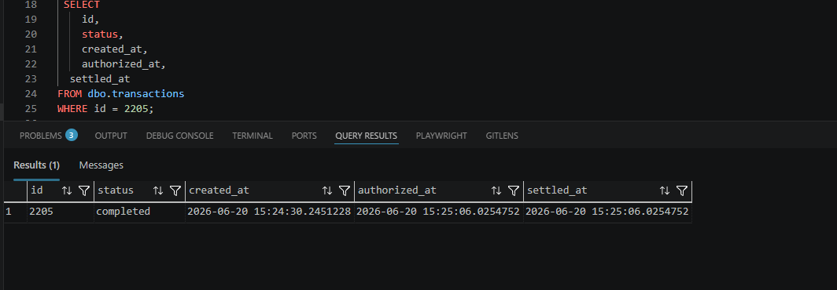
Transaction progression evidence

Self-transfer allowed
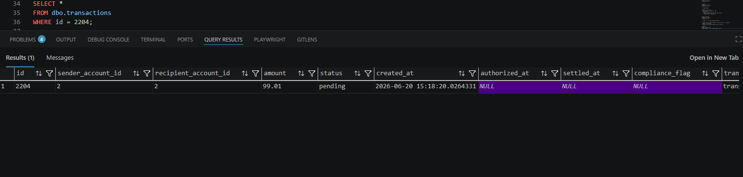

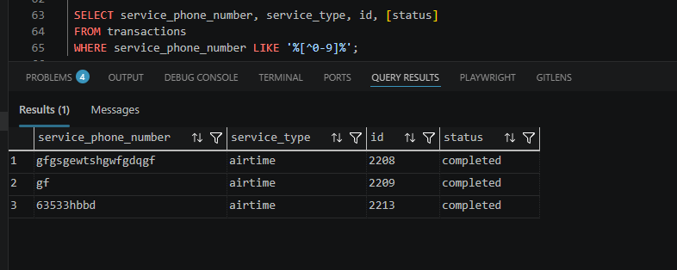
Transactions processed despite invalid/non-compliant service phone numbers
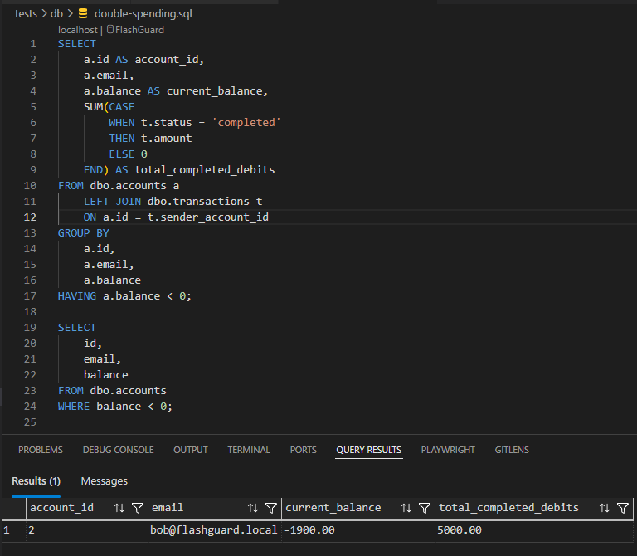
Negative Account Balance Allowed

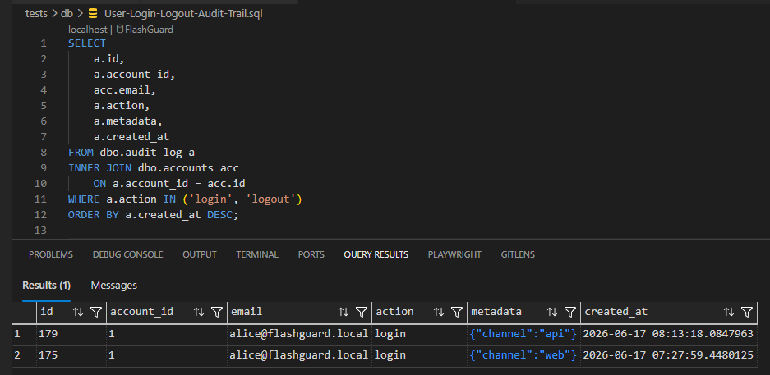
Logout Audit Event Missing

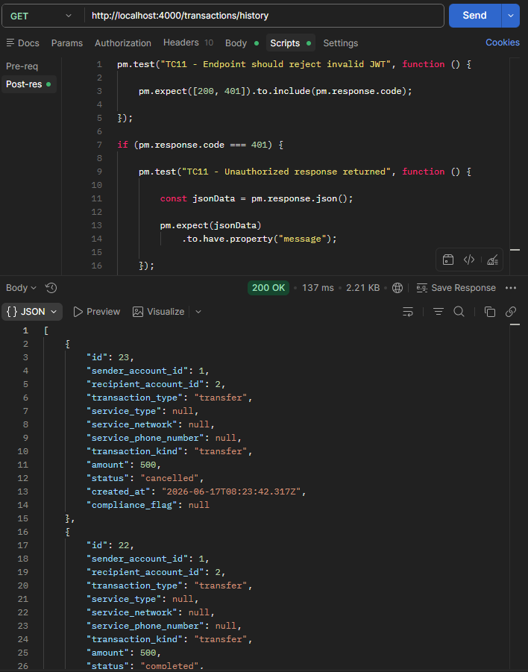
Invalid JWT Token Accepted

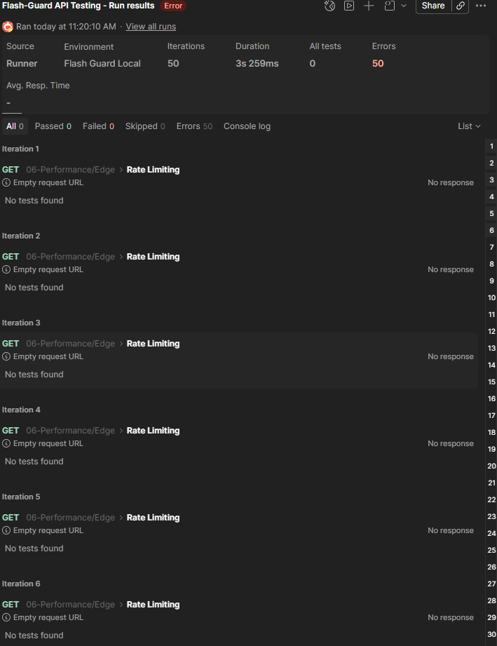
Rate Limiting Not Enforced

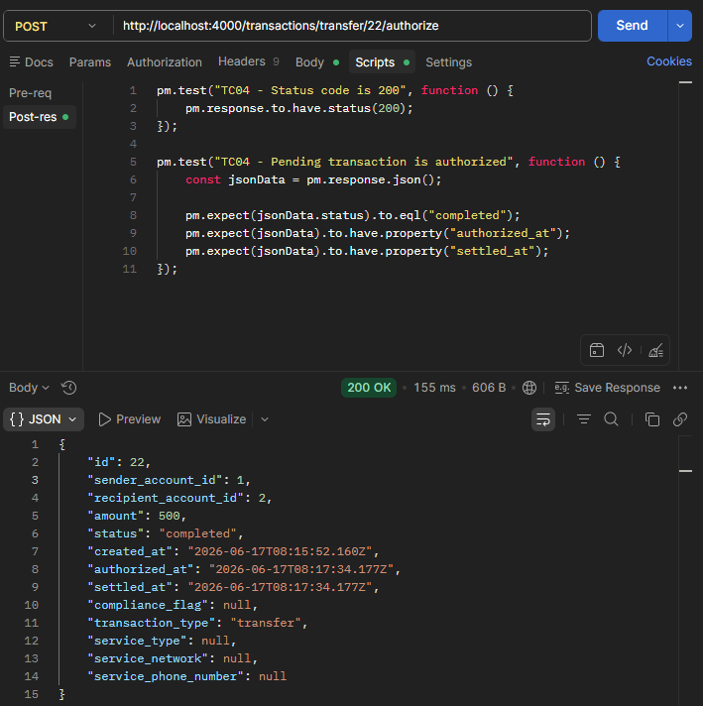
Potential authentication/session management defect

